HAZ45.3 Notes
(Changes from HAZ45.2 highlighted)

TABLE OF CONTENTS
Page
1. HAZ45 PSHA CODE 1
1.1 Fault File Notes 1
1.2 Run File Notes (Run Option 0) 9
1.3 Attenuation File Notes (Run Option 1) 12
1.4 Spectra File Notes (Run Option 2) 14
2. UHS CODE 17
3. FRACTILES CODE 18
4. FREQUENTLY ASKED QUESTIONS 19
4.1 How do you run HAZ45? 19
4.2 How do you compile the code? 21
4.3 How do you specify a characteristic magnitude pdf? 22
4.4 How do you specify a truncated exponential magnitude pdf? 22
4.5 How do you specify a maximum magnitude pdf? 23
4.6 How do you specify a boxcar magnitude pdf? 24
4.7 How does the code model areal zones? 25
4.8 How does the code model gridded seismicity? 25
4.9 How does the code implement variable step size? 26

HAZ45 PSHA CODE
HAZ45 is a seismic hazard computer program primarily used to perform probabilistic seismic hazard analysis. The code is written in Fortran and these notes explain the necessary format for the input source parameters. More complicated seismic sources may require the user to examine the Fortran subroutine to make sure that the fault file is in the correct format. Inputs are specified in free format. In this note, line numbers are indicated sequentially, however, because additional lines may be required given an input parameter value (e.g., if a source is defined by a slip rate, moment rate, or recurrence interval, etc.) the actual line numbers may not correspond to a given fault file scenario. Lines which must be grouped together are given the same numeric value but have the additional letter classification (e.g., 5a, 5b, etc.). While some effort is made to maintain backward compatibility with older versions of fault files, it is recommended that users update to the 45.3 format described below.

Fault File Notes
Line 1: iCoor
0=(x,y) in km, 1=(x,y) in longitude and latitude
Line 2: nflt
Number of defined faults. This number of faults is the total number of fault systems, as a given fault system can have multiple segments and associated combinations of segments. Program will loop over nflt when reading fault file.
Line 3: faultname
Text string for given fault system.
Line 4: Prob Activity
Probability of activity for given fault system.
Line 5a: nSeg Model
Number of segmentation models for given fault system.
Line 5b: wts
Number of nSeg Model weights (see line 5a). Weights must sum to unity.
Line 6a: total number of sources
Total number of sources (i.e., segments) which define a given fault system. Note that only the individual segments should be defined in the fault file (older versions of the hazard code required each combination of segments to be defined individually which a fault file). The fault file will repeat for each individual segment.
Line 6b: flags for segment model
For each segment model (see Line 5a) the file must define which segments are contained within each segment model through the use of flags. As an example, if a fault system has four individual fault segments and two segmentation models consisting of the first two segments for model 1 and the second two segments for model 2 the fault file would have flags as follows:

1 1 0 0 flags for segment model 1
0 0 1 1 flags for segment model 2
Note that not every defined fault segment must be included in a segmentation model and also that individual segments can be included in multiple segment models.
Line 7: segment fault name
Text string for individual fault segment name.
Line 8: Source type, Atten Type, sample step (km), dirflag, synflag
The source type value is used to classify different types of sources as follows:

1 – Mapped linear fault source
2 – Areal source zone
3 – Gridded seismicity source
4 – Non-uniform gridded seismicity source
5 – Special geometrically defined fault source

The attenuation type flag is dependent on the types of attenuation models defined in the input file for Haz45. As an example, one could have crustal attenuation models defined as type 1 and subduction attenuation models defined as type 2 in the input file. For that example, the user would want to associate the seismic source type (i.e., crustal versus subduction) with the different types of attenuation models defined in the input file.

The sample step size is the step size in km used in the sampling of the areal source zone. Note that for large areal sources a larger step size will decrease the run time of the program. However, for cases where a site is located within the areal source zone, this step size should not be too large as to bias the resulting hazard.

The dirflag is a parameter with values of either 0 (no directivity) or 1 (directivity). This allows the user to pre-determine which faults will include the features of the directivity model in the analysis. Because this option of including directivity for sources will slow down the computer run time, faults which are not considered to contribute directivity (e.g., located far away from the site) effect can be de-selected for the analysis.

The synflag is a parameter with the values of either 0 (no synchronous rupture) or 1 (synchronous rupture). This parameter was implemented for a special study in which the rupture of a given fault triggered a large earthquake on a neighboring fault. Because this was a special case which was implemented in the hazard code, the most common and default value for this flag is 0.
Line 9: Aleatory segment wts
Aleatory segment weight for this individual segment. Note that the value does not need to be 1.0.
Line 10: dip, depth to top
Dip angle for given fault source. Convention is positive dip angle is when looking down the defined strike of the fault the hanging wall is on the right. Negative dip angle when looking down the strike of the fault and the hanging wall is on the left side. This dip represents the based dip angle which can be varied based on input parameters given later in the fault file.

Depth to the top of the fault trace. This is needed for the new NGA attenuation relationships and is defined in km.

Note that this input parameter line is not needed for sourceType=5.
Line 11: The input parameters given on this line depend on the defined source type (see Line 8).
For Source Type = 1 or 2
npts
x₁, y₁
x₂, y₂
…
Number of points which define the source followed by the defining points in either km or longitude and latitude depending on the Line 2 parameter value.
For Source Type = 3 or 4
Grid filename
Text filename for gridded seismicity source.
For Source Type = 5
nDowndip, npts
x_{1top}, y_{1top}, depth1, x_{1bot}, y_{1bot}, depth2
x_{2top}, y_{2top}, depth1, x_{2bot}, y_{2bot}, depth2
…
Number of downdip points which define the special geometry case. For this case, the fault is defined based on multiple points defined in space (i.e., longitude, latitude and depth or x, y, and depth). The number of points must be equal for each number of downdip points. This feature was added to allow for the modeling of faults which are not rectangular projections from the upper fault trace.
Line 12a: number of dip variations
Number of dip variation values. These absolute values will be applied to the input dip value given in Line 10 earlier in the fault file. Values can be either positive or negative.
Note that this input parameter line is not needed for sourceType=5.
Line 12b: dip variation values
Listing of dip variation values.
Note that this input parameter line is not needed for sourceType=5.
Line 12c: wts for dip variation values
Listing of dip variation value weights. Total must sum to unity. Note that this input parameter line is not needed for sourceType=5.
Line 13a: number of b-values
Number of b-values which will be used with the slip rate, moment rate, and recurrence interval calculations. These b-values are not used with the activity rates (see later section in the fault file). If a source is completely defined by the activity rate, this value can have value of zero.
Line 13b: b-values
Listing of b-values which will be used with the slip rate, moment rate, and recurrence interval calculations. These b-values are not used with the activity rates (see later section in the fault file). This line is not needed if the number of b-values (line 13a) is zero.
Line 13c: wts for b-values
Listing of b-values weights. Total must sum to unity. This line is not needed if the number of b-values (line 13a) is zero.
Line 14a: number of activity rates
Number of activity rates for the given seismic source. This parameter can be zero if the source is not defined by the activity rates in which case lines 14b is not needed for the program.
Line 14b: b-value, act rate, wts
Listing of b-values, activity rates, and associated weights. These lines are not needed if the number of activity rates is zero (line 14a).
Line 15: wts for slip rates, wt for Act Rates, wt for Rec. Int., wts for MoRate
Group weights for slip rate, activity rates, recurrence intervals, and moment rates. Weights must sum to 1.0
Line 16a: number of slip rates
Number of slip rates for the given seismic source. This parameter can be zero if the source is not defined by the slip rates in which case lines 15b and 15c are not needed for the program.
Line 16b: slip rate values
Listing of slip rate values (mm/yr) for the given source. This line is not needed if the number of slip rate values (line 16a) is zero.
Line 16c: wts for slip rate values
Listing of slip rate values weights. Total must sum to unity. This line is not needed if the number of slip rate values (line 16a) is zero.
Line 17a: number of recurrence intervals
Number of recurrence intervals for the given seismic source. This parameter can be zero if the source is not defined by the recurrence intervals in which case lines 17b and 17c are not needed for the program.
Line 17b: recurrence intervals
Listing of recurrence intervals (years) for the given source. This line is not needed if the number of recurrence intervals (line 17a) is zero.
Line 17c: wts for recurrence intervals
Listing of recurrence intervals weights. Total must sum to unity. This line is not needed if the number of recurrence intervals (line 17a) is zero.
Line 18a: number of moment rates
Number of moment rates for the given seismic source. This parameter can be zero if the source is not defined by the moment rates in which case lines 18b, 18c and 18d are not needed for the program.
Line 18b: moment rates
Listing of moment rates (dyne*cm/year) for the given source. This line is not needed if the number of moment rates (line 18a) is zero.
Line 18c: moment rate reference depths
Reference depth (in km) for each moment rate. Given moment rate will be scaled by the ratio of reference depth divided by the thickness values listed later in the fault file. Not needed if number of moment rates (line 18a) is zero.
Line 18d: wts for moment rates values
Listing of moment rate values weights. Total must sum to unity. This line is not needed if the number of moment rates (line 18a) is zero.
Line 19a: nRecur
Number of recurrence models for a given source.
Line 19b: recurrence models
Listing of recurrence models for the given source. Recurrence models are defined as:

0 = Characteristic
1 = Truncated exponential
3 = Maximum magnitude
8 = Boxcar
10 = WAACY Model
Line 19c: wts for recurrence models
Listing of recurrence model weights. Total must sum to unity.
Line 19d: magnitude parameters (mpdf1, mpdf2, mpdf3)
Listing of additional magnitude parameters for each recurrence model as follows:

Characteristic Model
mpdf1 = magnitude width of the characteristic box, usually defined as 0.5.
mpdf2 = delta magnitude2, usually taken as 1.0.
mpdf3 = magnitude value to increase the mean characteristic magnitude defined later in the fault file. Usually this value should 0.5 of mpdf1 (i.e. 0.25).
Truncated exponential Model
mpdf1 = magnitude value to increase the reference magnitude to, defined later in the fault file, set the maximum magnitude. Mmax = refmag + mpdf1
mpdf2 = delta magnitude2, quantify how much of the truncated exponential model is derived from a recurrence interval
mpdf3 = reference magnitude. (limit same as mpdf6 on waacy)

Note: For most truncated exponential model cases the parameter values for mpdf1 and mpdf2 should be entered as 0.0

Maximum magnitude Model
mpdf1 = magnitude adjustment value to decrease the reference magnitude defined later in the fault file
mpdf2 = sigma value in magnitude units
mpdf3 = magnitude adjustment value which defines the upper range in the distribution given the mean reference magnitude defined later in the fault file.

Boxcar Model
mpdf1 = magnitude width of the boxcar, e.g., 0.5. The reference magnitude defined later in the fault file is the center of the boxcar, so magnitudes range uniformly from refmag – mpdf1/2 to refmag + mpdf1/2.
mpdf2 = not used (enter 0.0)
mpdf3 = not used (enter 0.0)

Note: The boxcar model is currently only available for sources defined by activity rates.

WAACY Model
mpdf1 = sigmaM
mpdf2 = absolute maximum magnitude (Mmax, if mpdf5 = 0)
mpdf3 = btail (slope of tail)
mpdf4 = fraction of the moment in the exponential 1 portion
mpdf5 = constant (alternative maximum magnitude = reference magnitude + constant)
mpdf6 = maxmag limit (constant + reference magnitude not to exceed max
Line 20a: number of fault thicknesses
Number of fault thicknesses for a given source.
Note that this input parameter line is not needed for sourceType=5.
Line 20b: fault thicknesses
Listing of fault thicknesses.
Note that this input parameter line is not needed for sourceType=5.
Line 20c: wts for fault thicknesses
Listing of fault thicknesses weights. Total must sum to unity.
Note that this input parameter line is not needed for sourceType=5.
Line 21: Depth pdf model and parameters (dp1, dp2, dp3)
0 = uniform distribution
1 = normal distribution
2 = triangle distribution
3 = trapezoid distribution (pending)
model parameters dp1, dp2 and dp3 to define model.
For uniform: dp1=0, dp2=0, dp3=0
For normal: dp1 = mean depth in km, dp2 = std dev of depth, dp3=0
For triangle: dp1, dp2 and dp3 are the depths of the three points of the triangle
Line 22a: number of reference magnitudes
Number of reference magnitudes for a given source for each fault thickness (lines 22a-c must be repeated for each fault thickness – line 20a described above).
Line 22b: reference magnitudes
Listing of maximum magnitudes.
Line 22c: wts for reference magnitudes
Listing of reference magnitude weights. Total must sum to unity.
Line 23: MinMag, magstep, hxstep, hzstep, nRuparea, nRupwidth, mindepth
Minimum magnitude for given source used in the PSHA (usually Mw=5.0).
Magnitude step size to be used in the PSHA (usually 0.1).

Step size in km along fault strike. Step size in km down-dip. Recommended value of 1.0 km or less for sources which are located close to the site. Note also that hxstep must equal hystep for fault sources and the program will check for this and stop upon non-equal values.

Number of rupture areas, number of rupture widths, and minimum depth in km (used for some pre-NGA attenuation relationships which require a minimum depth).

Hxstep= -999, Hzstep= -999 Tells the program to use a variable step feature where point sources are spaced farther apart as you get farther from the site. For source types 2, 3, and 4 only.
Line 24a: Coefficients (a and b) and sigma for magnitude-rupture area relationship
Coefficients used in the magnitude-rupture area relationships and associated sigma in Log10 units. Usually taken from Wells and Coppersmith (1984) relationships.

Alternative option:
Leonard 2010 form: first coefficient is a flag = -999
second coefficient is C₂ (e.g., 3.7)
Alternative option also requires sigma area in log10 units
Line 24b: Coefficients (a and b) and sigma for magnitude-width area relationship
Coefficients used in the magnitude-rupture width relationships and associated sigma in Log10 units. Usually taken from Wells and Coppersmith (1984) relationships.

Alternative options:
Leonard 2010 form: first coefficient is a flag = -999
second coefficient is C₁ (e.g., 15)
Constant aspect ratio: first coefficient is a flag = -888
second coefficient is AR (e.g., 1.5)
NGA-West2 aspect ratio: first coefficient is a flag = -777
second coefficient is a (e.g., -4.254)
third coefficient is b (e.g., 0.785)
Alternative options also require sigma width (not sigma aspect ratio) in log10 units
Line 25a: number of fault mechanism models
Number of fault mechanism models for a given source.
Line 25b: wts for fault mechanism model
Listing of fault models.
Line 25c: number of fault mechanisms
Number of individual mechanism types. Mechanism types are dependent on selected attenuation relationship.
Line 25d ftype(s)
Fault mechanism type(s). In general the following are used for two different classes of attenuation models:
Crustal Models
0 = Strike-slip
0.5 = Oblique/Strike-slip
1.0 = Reverse
-0.5 = Oblique/Normal
-1.0 = Normal
Subduction Models
0 = interface events
1 = intraslab events
Line 25e: wts for fault mechanisms
Listing of fault mechanism weights. Total must sum to unity.

Run File Notes (Run Option 0)
Similar to the different format of the fault file from previous versions of the hazard code, the current version (HAZ45.3) requires an input file with a new format which is not backwards compatible with the previous versions. The new version is described below.
Line 1: faultfile
Filename of the fault file. Note this ascii string does not need to be bracketed with quotation marks.
Line 2: version
Version number of fault file listed in Line 1 above.
(e.g., 45.2 or 45.3)
Line 3: minlat, maxlat, minlong, maxlong
Minlat = minimum latitude for analysis
Maxlat = maximum latitude for analysis
Minlong = minimum longitude for analysis
Maxlong = maximum longitude for analysis
Line 4: maxdist
Maximum distance used in the analysis. Sources which are beyond this distance are not used in the analysis even if they are defined in the fault file.
Line 5: Title String
Text title string which will be echoed to output files.
Line 6: nProb, nAttentype
Number of problems (i.e., specific spectral acceleration periods) for the analysis.
Number of attenuation model types which will follow (e.g., crustal models, subduction models, etc.). The corresponding fault file must have at least one source defined for each nAttentype model.
Line 7: specT, maxEps, dirflag, pcflag
Spectral period for given nProb case, maximum epsilon value for the analysis, directivity flag for given nProb case, flag for polynomial chaos method.

Directivity flag values are defined as follows:

0 = No directivity
30 = Bayless and Somerville (2015)
105 = JWL (2015) uniform hypocenter for SS and RV flts
106 = JWL (2015) preferred model for SS (SWUS, App D) and RV (Ch. 3)

Directivity model will only be applied to those sources which have their directivity flag option defined in the fault file regardless of the dirflag value defined in the input file.

Polynomial chaos flags are defined as follows: 0 = standard method, 1 = polynomial chaos with full correlation. Use of the polynomial chaos method requires specification of a mean ground motion model. The method is currently implemented with a hard-coded sigma_mu = 0.3 natural log units.

This line must be repeated in the input file nProb times with each time following the next three lines.
Line 8: nZ-values, Z-values
Number of ground motion values, and ground motion values defined in units of g.
Line 9: nGMmodels
Number of ground motion models for each nAttentype.
Line 10: jCalc, const1, const2, wts, VarAdd, iMixFlag
Specific jcalc number to identify requested attenuation model, constant 1 and 2 which are applied to the median ground motion values defined in natural log units, weight for given attenuation model, and sigma adjustment value given as variance (i.e., sigma*sigma) in natural log units. For this sigma adjustment the revised sigma value (Sigma’) for a given attenuation model will be computed based on adjusting the variance as follows:

Sigma’ = Sqrt( Sigma*Sigma + VarAdd)

Note that if the user requests a negative adjustment which is greater than the model variance the resulting Sigma’ value will be set equal to 0.0. This line needs to be repeated nGMmodels times and the weights should sum to unity.

Set iMixFlag to 1 for SWUS mixture model and to 0 for standard log-normal

Note: The user is able to define a sigma model independent of the median model. The line 10’ format shall be used when jcalc is negative:
Line 10’: -jCalc, const1, const2, wts, VarAdd, iMixFlag, sCalc, sFix
This allows user define an alternative sigma model through the sCalc or sFix. The sCalc is the jCalc for the desired GMPE model which sigma is to be used from. If sCalc is negative, sFix will be used. sFix is a constant sigma to be applied to the hazard.
Line 11: psCorflag
Point source correction flag with the following options:
0 = no correction
1 = apply correction
Line 12a: nMagBin
Number of magnitude bins for resulting output deaggregation data.
Line 12b: MagBin
Specific magnitude values for the magnitude bins for the deaggregation results.
Line 13a: nDistBin
Number of distance bins for resulting output deaggregation data.
Line 13b: DistBin
Specific distance values for the distance bins for the deaggregation results.
Line 14a: nEpsBin
Number of epsilon bins for resulting output deaggregation data.
Line 14b: EpsBin
Specific epsilon values for the epsilon bins for the deaggregation results.
Line 15a: nCosTBin
Placeholder for future directivity deaggregation
Line 15b: CosTBin
Placeholder for future directivity deaggregation
Line 16: soilAmpflag
Flag to apply soil amplification factors (0=no, 1=yes)
Line 17: nSites
Number of sites to analysis for the given input file.
Line 18: Sitelong, sitelat, Vs30m, Z1.0, Z1.5, Z2.5, Vrup, Forearc
Site location longitude and latitude in either degrees or km as defined in the fault file, Vs30 (m) for given site, depth to the 1.0km/sec boundary (km), depth to 1.5km/sec boundary (km), depth to 2.5km/sec boundary (km), rupture velocity as a decimal percentage of the shear wave velocity at the seismic source and Forearc flag (0=Forearc site location, 1=backarc site location). Some of these parameters are only used for specific attenuation models and the NGA directivity model. Values must be entered in the input even if they are not needed for the analysis.
Line 19-24: filenames for output files.
(Outfiles in numerical order)
out1 Individual hazard curves, used with the companion fractile program
out2 Magnitude recurrence curves, used with the companion SSC fractile program
out3 Mean hazard curve results, used with companion UHS_deagg program
out4 Deaggregation information, used with companion UHS_deagg program
out5 SSC tornado output file
out6 GMC tornado output file
out7 Deaggregation by source

Attenuation File Notes (Run Option 1)
The hazard code can also be used to compute attenuation curves for any ground motion model which is currently coded in the hazard code. To invoke this option the user should select run option 1 at the start of the program. The necessary input file is described below. Note that not all input parameters are used depending on the selected ground motion models; however, values must be entered in the input file.

Line 1: title
Title text string which will be written to the output file. Note this ascii string does not need to be bracketed with quotation marks.
Line 2: fileout
Filename of the ouptut file. Note this ascii string does not need to be bracketed with quotation marks.
Line 3: nCalc
Number of attenution curves to generate. Input file must repeat lines 4 – 12, nCalc times.
Line 4: jCalc, const1, const2, VarAdd
Specific jcalc number to identify requested attenuation model, constant 1 and 2 which are applied to the median ground motion values defined in natural log units, and sigma adjustment value given in natural log units. For this sigma adjustment the revised sigma value (Sigma’) for a given attenuation model will be computed based on adjusting the variance as follows:

Sigma’ = Sqrt( Sigma*Sigma + VarAdd)

Note that if the user requests a negative adjustment which is greater than the model variance the resulting Sigma’ value will be set equal to 0.0. This line needs to be repeated nGMmodels times and the weights should sum to unity.

Note: The user is able to define a sigma model independent of the median model. The line 4’ format shall be used when jcalc is negative:
Line 4’: -jCalc, const1, const2, VarAdd, sCalc, sFix
This allows user define an alternative sigma model through the sCalc or sFix. The sCalc is the jCalc for the desired GMPE model which sigma is to be used from. If sCalc is negative, sFix will be used. sFix is a constant sigma to be applied to the hazard.
Line 5: mag
Magnitude for attenuation model.
Line 6: nDist
Number of distance for each attenuation curves case.
Line 7: rRupdist, JBDist, SeismoDist, Hypodist, Rx, Ry0
Rupture distance, Joyner-Boore distance, seismogenic distance, hypocentral distance, Rx distance, and Ry0 distance in km. Line must be repeated nDist times.
Line 8: fType, Dip, HWFlag
Fault mechanism type depending on the selected attenuation model, dip angle for the given case and hanging wall flag (0=Footwall, 1=hanging wall site).
Line 9: Vs30m, Vs30Class, Forearc
Vs30m value in m/sec and flag to indicate if this value is measured (1) or estimated (0). Forearc flag is used for certain subduction models with 0=Forearc site location and 1=backarc site location.
Line 10: HypoDepth, Width
Hypocentral depth and rupture width in km.
Line 11: Z1.0, Z1.5, Z2.5, Ztor
Depth to the 1.0, 1.5, and 2.5km/sec boundary in units of km. Ztor is the depth to the top of the rupture
Line 12: specT
Spectral period for the given case.

Spectra File Notes (Run Option 2)
The hazard code can also be used to compute acceleration response spectra for any ground motion model which is currently coded in the hazard code. To invoke this option the user should select run option 2 at the start of the program. The necessary input file is described below. Note that not all input parameters are used depending on the selected ground motion models; however, values must be entered in the input file.

Line 1: title
Title text string which will be written to the output file. Note this ascii string does not need to be bracketed with quotation marks.
Line 2: fileout
Filename of the ouptut file. Note this ascii string does not need to be bracketed with quotation marks.
Line 3: nCalc
Number of spectra to generate. Input file must repeat lines 4 – 13, nCalc times.
Line 4: jCalc
Jcalc specifying the selected spectra model for a given case.
Line 5: mag
Magnitude for spectra.
Line 6: nDist
Number of distance for each spectra case.
Line 7: rRupdist, JBDist, SeismoDist, Hypodistance, Rx, Ry0
Rupture distance, Joyner-Boore distance, seismogenic distance, hypocentral distance, Rx distance, and Ry0 distance in km. Line must be repeated nDist times.
Line 8: fType, Dip, HWFlag
Fault mechanism type depending on the selected attenuation model, dip angle for the given case and hanging wall flag (0=Footwall, 1=hanging wall site).
Line 9: Vs30m, Vs30Class, Forearc
Vs30m value in m/sec and flag to indicate if this value is measured (1) or estimated (0). Forearc flag is used for certain subduction models with 0=Forearc site location and 1=backarc site location.
Line 10: HypoDepth, Width
Hypocentral depth and rupture width in km.
Line 11: Z1.0, Z1.5, Z2.5, Ztor
Depth to the 1.0, 1.5, and 2.5km/sec boundary in units of km. Ztor is the depth to the top of the rupture
Line 12: nper
Number of spectral period to compute for a given case. Note that if spectral periods are requested which fall outside of the defined spectral period range of a given attenuation model, the program will return null values of ‘-99.9999.’ For spectral periods which fall within the defined period range of a given attenuation model but are not at the specific defined spectral periods of the model will be estimated based on an interpolation of the attenuation model coefficients and these spectral acceleration values will be noted in the output file.
Line 13: specT, const1, const2, VarAdd
nPer spectral periods for the given case, constant 1 and 2 which are applied to the median ground motion values defined in natural log units for each period, and sigma adjustment value given in natural log units for each period. For this sigma adjustment the revised sigma value (Sigma’) for a given attenuation model will be computed based on adjusting the variance as follows:

Sigma’ = Sqrt( Sigma*Sigma + VarAdd)

Note that if the user requests a negative adjustment which is greater than the model variance the resulting Sigma’ value will be set equal to 0.0. This line needs to be repeated nGMmodels times and the weights should sum to unity.

Note: The peak ground acceleration and peak ground velocity may be output by specifying specT values of 0 and -1, respectively.

Note: The user is able to define a sigma model independent of the median model. The line 4’ format shall be used when jcalc is negative:
Line 4’: -jCalc, const1, const2, VarAdd, sCalc, sFix
This allows user define an alternative sigma model through the sCalc or sFix. The sCalc is the jCalc for the desired GMPE model which sigma is to be used from. If sCalc is negative, sFix will be used. sFix is a constant sigma to be applied to the hazard.

UHS CODE
The post processing program is structured to work with the current version of the PSHA program, Haz45.3. Uniform hazard spectra and deaggregation matrices will be computed based on user defined input parameters and the associated output files from PSHA runs using the Haz45.3 program. The input file is described below.

Line 1: fltout
Output filename for the results. Note that this filename does not need to be bracketed with quotation marks.
Line 2a: naep
Number of hazard levels to compute both the uniform hazard spectra at and the deaggregation matrices.
Line 2b: aep
Naep hazard levels.
Line 3: nSpecT
Number of spectral periods. Repeat lines 4a-b and lines 5a-b nSpecT times.
Line 4a: meanHCFile
Filename for the mean hazard curve output file from Haz45. Note that this filename does not need to be bracketed with quotation marks.
Line 4b: nCurve, period
Sequential number of requested hazard curve from the meanHCFile ouput for the given spectral period. For example, if the meanHCFile contains mean hazard curves in the following order: PGA, 0.2, 0.3, and 1.0 sec and the program is operating on the 1.0 sec case, nCurve would be equal to 4. Period is the spectral period for the given hazard curve.
Line 5: dummy
Space text line to visually differentiate the grouping of mean hazard curve files and deaggregation files.
Line 6a: meanDeagFile
Filename for the mean deaggregation output file from Haz45. Note that this filename does not need to be bracketed with quotation marks.
Line 6b: nCurve, period
Sequential number of requested deaggregation curve from the meanDeagFile ouput for the given spectral period. For example, if the meanDeagFile contains mean deaggregation output in the following order: PGA, 0.2, 0.3, and 1.0 sec and the program is operating on the 1.0 sec case, nCurve would be equal to 4. Period is the spectral period for the given deaggregation case.

FRACTILES CODE
The post processing program will compute the fractiles from a seismic hazard run. This version of the program works with the seismic hazard code version Haz45 or later. The fractiles are computed based on a Monte Carlo simulation. This version is able to read fault files in which synchronous rupture is modeled.

Line 1: iSeed
A large prime number to be used for the random number generator
Line 2: nSample
Number of samples for randomization
Line 3: nPer
Number of spectral periods to perform fractile analysis on from a given hazard run.
Line 4: nHazLevel, HazLevel
Number of UHS values and UHS values. The 5th, 10th, 50th, 90th,
and 95th fractile levels will be returned for each UHS value.
Line 5: fractile output file
Filename for the fractile hazard output file.
Line 6: iPer
Index number of spectral period to perform fractile analysis
Line 7: Hazard run filename
Hazard run “Option 0” file from PSHA run, see Haz45-Notes for formatting.
Line 8: Out1 filename
Name of out1 file from Haz45 run

FREQUENTLY ASKED QUESTIONS

How do you run HAZ45?
The program executable can be run from the command line. This example will utilize a test from the PEER PSHA Code Verification Project to demonstrate how to run HAZ45.
Copy the folder S2Test1 from the PEER Verification Tests folder over to your working directory. My working directory will be on my C drive in a folder called Demonstration:
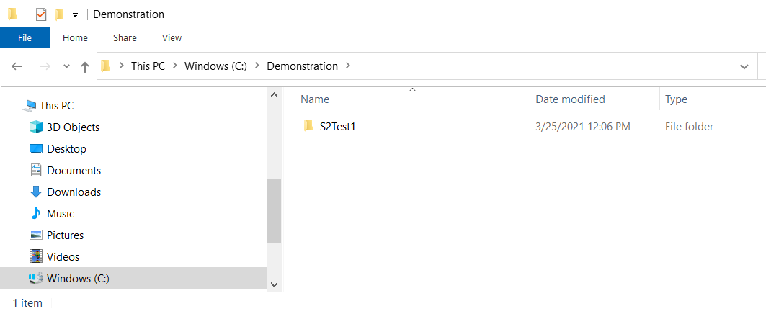
Open a command terminal and navigate to your working directory inside the folder with the input files. The command prompt cd stands for change directory:
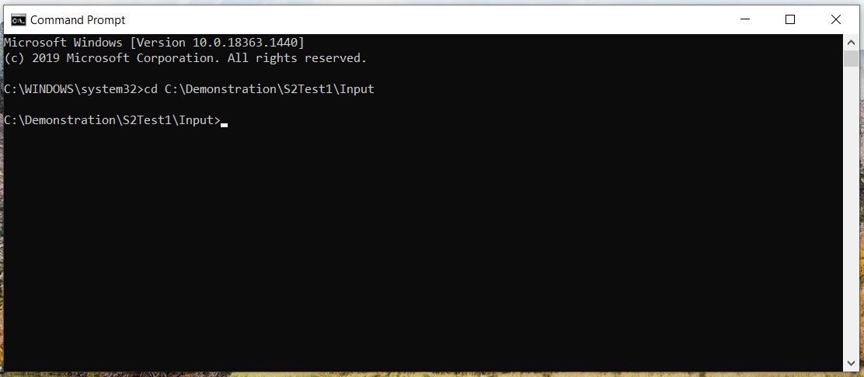
The executable can be located in a different location. My executable is on my C drive in a folder called Fortran_programs:
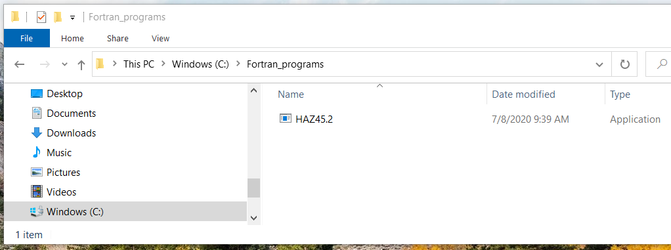
From the command terminal, run the program by typing the name of the executable and hitting enter. The program will prompt you for input. Type 0 and hit enter. When prompted type 0 and hit enter again. When prompted type Run_S2Test1.txt:
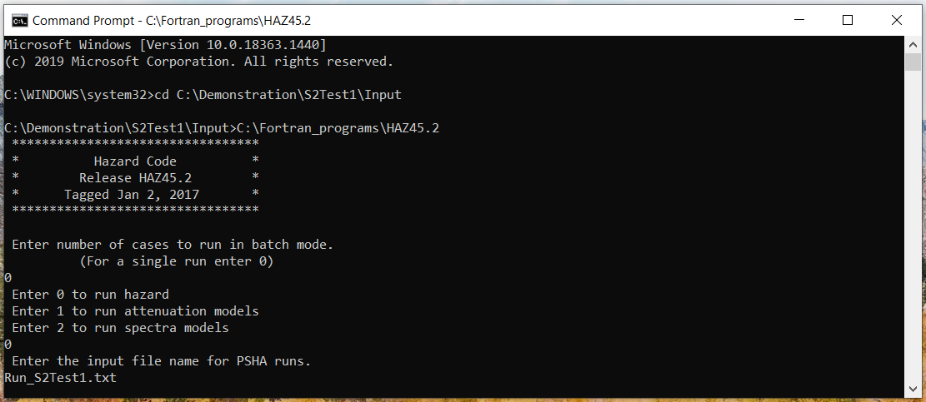
Hit enter and the program will begin to run, echoing information to the screen as an indicator of progress. A successful run ends with Normal termination:
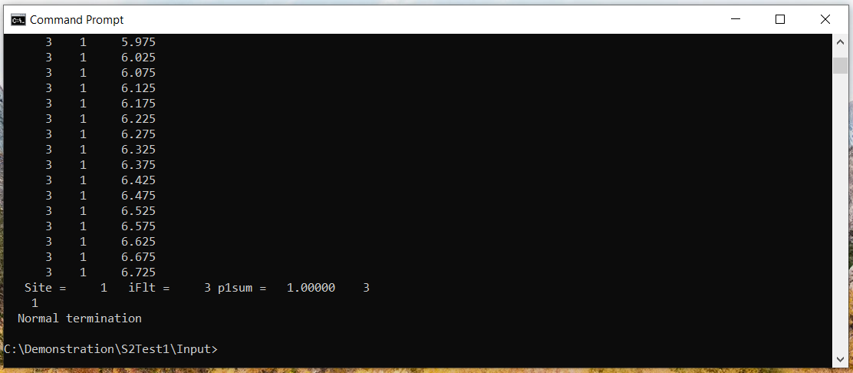
Several output files are created by the program. To make a plot of the mean total hazard use the out3 file with the AMP: and Wt_Total_Events/yr rows:
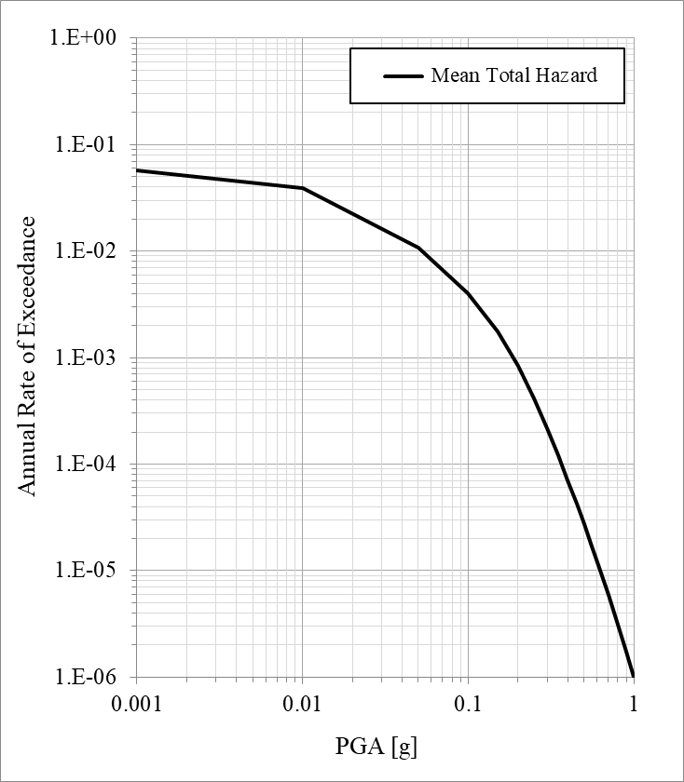

How do you compile the code?
Providing instructions for installing a Fortran compiler are beyond the scope of these notes; however, if you have the GFortran compiler installed and working on your computer, the code can be modified and recompiled with the following line:
gfortran -ffixed-line-length-132 -fno-automatic -o HAZ45_d_Aug30 *.F *.f
In the above line I’ve named the program executable HAZ45_d_Aug30 to indicate that I’m compiling the develop branch from github with commits through August 30th.

How do you specify a characteristic magnitude pdf?
The characteristic model (Young’s and Coppersmith 1985) is recurrence model 0. The shape of this magnitude probability density function is that of an exponential and boxcar distribution. The following is an example:
b-value 0.9
MinMag 5.0 mpdf1 0.5
Maximum Magnitude 6.5 mpdf2 1.0
Magstep 0.01 mpdf3 0.25
The code uses these inputs to compute the True Max (the largest magnitude in the distribution):
True Max = Maximum Magnitude + mpdf3 6.75 = 6.5 + 0.25
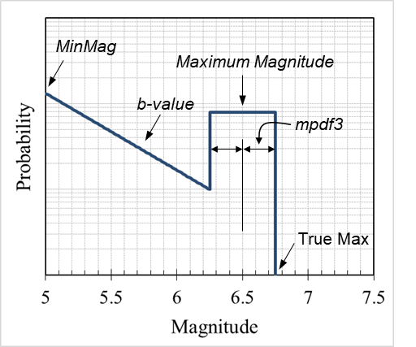

How do you specify a truncated exponential magnitude pdf?
The truncated exponential model (Gutenberg-Richter law) is recurrence model 1. The shape of this magnitude probability density function is that of a truncated exponential distribution. The following is an example:
b-value 0.9
MinMag 5.0 mpdf1 0.0
Maximum Magnitude 6.5 mpdf2 0.0
Magstep 0.01 mpdf3 0.0
The code uses these inputs to compute the True Max (the largest magnitude in the distribution):
True Max = Maximum Magnitude + mpdf1 6.5 = 6.5 + 0.0
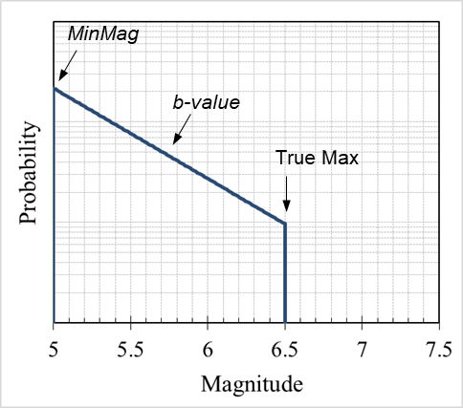

How do you specify a maximum magnitude pdf?
The maximum magnitude model (sometimes called pure characteristic) is recurrence model 3. The shape of this magnitude probability density function is that of a truncated normal distribution. The following is an example:
MinMag 5.0 mpdf1 0.4
Maximum Magnitude 6.6 mpdf2 0.25
Magstep 0.01 mpdf3 0.0
The code uses these inputs to compute the True Max (the largest magnitude in the distribution) and the Mean Characteristic (the magnitude corresponding to the peak of the distribution):
True Max = Maximum Magnitude + mpdf3 6.6 = 6.6 + 0.0
Mean Characteristic = True Max – mpdf1 6.2 = 6.6 – 0.4
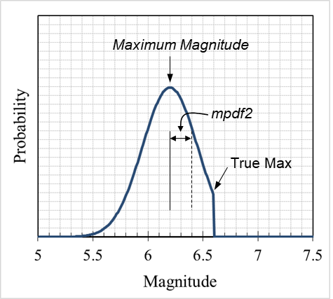

How do you specify a boxcar magnitude pdf?
The boxcar model (sometimes called the maximum moment model) is recurrence model 8. The shape of this magnitude probability density function is that of a uniform distribution. Unlike the other models, the Maximum Magnitude listed in the fault file is the center of the boxcar rather than the largest magnitude. The following is an example:
MinMag 5.0 mpdf1 0.5
Maximum Magnitude 6.5 mpdf2 0.0
Magstep 0.01 mpdf3 0.0
The code uses these inputs to compute the True Max (the largest magnitude in the distribution) and the True Min (the smallest magnitude in the distribution):
True Max = Maximum Magnitude + mpdf1 / 2 6.75 = 6.5 + 0.5 / 2
True Min = True Max – mpdf1 6.25 = 6.75 – 0.5
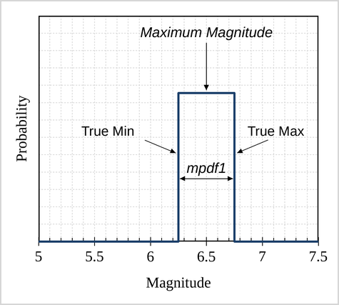
Every magnitude between the True Min and the True Max is equally likely. The boxcar model is currently only available for sources defined by activity rates.

How does the code model areal zones?
There are three different source types that model background seismicity.
The first is source type 2, which allows the user to specify an areal source zone as a polygon. The polygon is filled with point sources using the sample step input. The point sources are then grouped into bins based on their horizontal distance from the site and a probability density function is generated. The probability density function uses the hxstep input for the discretization. At each representative horizontal distance, additional point sources are generated to sample the depth of the seismogenic thickness. The hystep input is used for the depth discretization.

How does the code model gridded seismicity?
Another way the code models background seismicity is with a grid of cells. This is done with source type 3 or source type 4. The main difference between areal source zones and gridded seismicity is that an areal source zone has a single seismicity rate applied to the area, while each cell in the gridded seismicity approach can have a different seismicity rate. Similar to source type 2, source types 3 and 4 fill the grid cells with point sources using the sample step input. The point sources are then grouped into bins based on their distance from the site on the horizontal plane and a probability density function is generated. The probability density function uses the hxstep input for the discretization. At each representative horizontal distance, additional point sources are generated to sample the depth of the seismogenic thickness. The hystep input is used for this discretization.

How does the code implement variable step size?
The variable discretization implementation uses a finer spacing of point sources close to the site and a courser discretization of point sources far from the site. The distance on the horizontal plane is used to set the spacing, based on the following criteria:

Distance on horizontal plane | Point source spacing
< 10 km | 1 km
< 25 km | 2 km
< 60 km | 3 km
< 150 km | 4 km
≥150 km | 5 km

The point source spacing described above is utilized in two ways. First, a density function groups point sources at similar horizontal distances using this spacing on the horizontal plane. Second, the distribution of point sources with depth is sampled according to this point source spacing. The spacing with depth is adjusted as necessary such that the discretization increment fits evenly into the defined depth (e.g., for a crustal thickness of 15 km, an initial spacing of 2 km would be adjusted to 1.875 km).

Variable discretization is only available for source types 2, 3, and 4.

